BRACT’s
Vishwakarma Institute of Technology, Pune
Practical Implementation Sheet
Department: CSE-AI Semester: 5 Academic Year: 2026-27
Division: E Batch: 3 Practical No: 1
Roll no: - 73 PRN No: 12415152 Name of Student: Pranav Upare
Subject Name : Deep Learning

Problem Statement :
Install and configure TensorFlow/Keras in Google Colab. Perform data preprocessing, normalization, train-test split, and visualization on a sample dataset.
Algorithm :
- Import required libraries: TensorFlow and Matplotlib.
- Load the MNIST handwritten digits dataset and split it into training and testing sets.
- Normalize the pixel values of all images to the range [0, 1] by dividing by 255.
- Define the class names for the 10 digit categories (0-9) and verify a sample image and its label.
- Build a Sequential neural network model consisting of a Flatten layer (28x28 input), a Dense hidden layer with 128 neurons and ReLU activation, and a Dense output layer with 10 neurons and Softmax activation.
- Compile the model using the Adam optimizer, sparse categorical crossentropy loss function, and accuracy as the evaluation metric.
- Train the model on the training data for 5 epochs.
- Evaluate the trained model on the test dataset and print the test accuracy.
- Generate predictions on the test images and compare the predicted class with the actual class.
- Save the trained model to disk.
Code :
import tensorflow as tf
import matplotlib.pyplot as plt

(train_images, train_labels), (test_images, test_labels) = tf.keras.datasets.mnist.load_data()

train_images = train_images / 255.0
test_images = test_images / 255.0

print("Training Images:", train_images.shape)
print("Testing Images:", test_images.shape)
print("Training Labels:", train_labels)

plt.imshow(train_images[0], cmap='gray')
plt.colorbar()
plt.show()

class_names = [
"0",
"1",
"2",
"3",
"4",
"5",
"6",
"7",
"8",
"9"
]

print(class_names[train_labels[0]])

model = tf.keras.models.Sequential()

model.add(tf.keras.layers.Flatten(input_shape=(28,28)))

model.add(tf.keras.layers.Dense(128, activation='relu'))

model.add(tf.keras.layers.Dense(10, activation='softmax'))

model.compile(
optimizer='adam',
loss='sparse_categorical_crossentropy',
metrics=['accuracy']
)

model.fit(
train_images,
train_labels,
epochs=5
)

loss, accuracy = model.evaluate(test_images, test_labels)

print("Test Accuracy:", accuracy)

predictions = model.predict(test_images)

print(predictions[0])

print("Predicted:", class_names[predictions[0].argmax()])
print("Actual:", class_names[test_labels[0]])

model.save("mnist_model.keras")

Output :
1. Dataset shapes after loading:
Training Images: (60000, 28, 28)
Testing Images: (10000, 28, 28)

2. Sample image (index 0) with its class label:
Label: 5
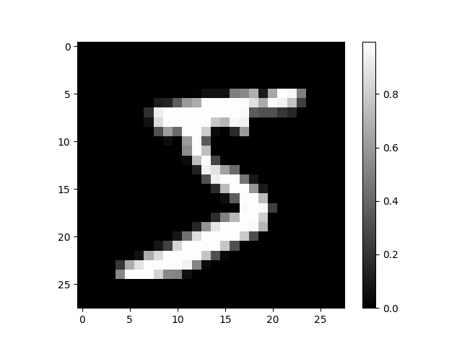

3. Model training (5 epochs):
Epoch 1/5 - accuracy: 0.9248 - loss: 0.2643
Epoch 2/5 - accuracy: 0.9660 - loss: 0.1150
Epoch 3/5 - accuracy: 0.9761 - loss: 0.0786
Epoch 4/5 - accuracy: 0.9822 - loss: 0.0576
Epoch 5/5 - accuracy: 0.9861 - loss: 0.0443

4. Model evaluation on test data:
Test Accuracy: 0.9757 (97.57%)

5. Sample prediction (test image index 0):
Predicted: 7
Actual: 7

Conclusion: The Artificial Neural Network was successfully trained on the MNIST handwritten digits dataset and achieved a test accuracy of approximately 97.57%, correctly classifying the sample test image as the digit '7'.

